Char ch = w ch is **declared as a variable with a data type o**f char **with initial value of** w

1. What is data type? Answer: C

1. Answer: A

1. Answer: D

1. Answer: a

1. Answer: d

1. Answer: D

Reserved words are words that cannot be used as object or variable names in a Java program because they're already used by the syntax of the Java programming language

1. Answer: A

1. Answer: C Boolean is for true and false only.

1. Answer: c

1. Answer: A

1. Answer: A

1. Answer: C

1. Answer: D

1. Answer: C

1. Answer: A

1. Answer: C

1. Answer: D

1. Answer: C

*String =* ***string***

*If no string but double, float present =* ***double***

*If no string, double, float, but nay long =* ***long***

*If no string, double, float, long =* ***int***

1. Answer: B

1. Answer: C

1. Answer: B

1. Answer: C

*Not all statements are expression, but all statements are expression.*

1. Answer: D

1. Answer: D

1. Answer: B

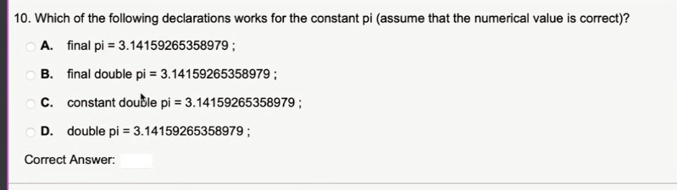

1. Answer:C

1. Answer:

1. Answer: D

1. Answer: A

1. Answer: D

If there is NEW operator, there is an object created.

1. Answer: A

1. Answer:

